**Practice 1: Direct provisioning of Azure File storage**

1. Login to Azure and connect to your AKS cluster.

2. Check if any pods run under the default namespace if so delete everything under the default namespace.

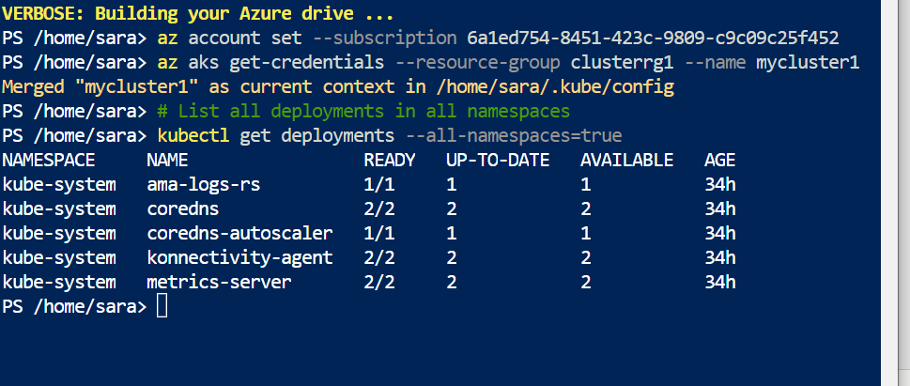

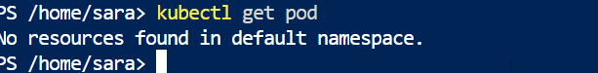

3. In this practice we will directly provision Azure Files to a pod running inside AKS.

4. First create the Azure Files share. Run the following commands:

# Change these four parameters as needed for your own environment

AKS_PERS_STORAGE_ACCOUNT_NAME=mystorageaccount$RANDOM

AKS_PERS_RESOURCE_GROUP=myAKSShare

AKS_PERS_LOCATION=eastus

AKS_PERS_SHARE_NAME=aksshare

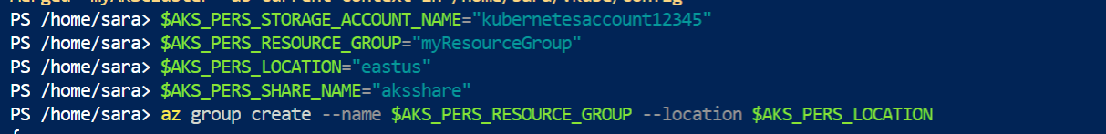

# Create a resource group

az group create --name $AKS_PERS_RESOURCE_GROUP --location

$AKS_PERS_LOCATION

# Create a storage account

az storage account create -n $AKS_PERS_STORAGE_ACCOUNT_NAME -g $AKS_PERS_RESOURCE_GROUP -l

$AKS_PERS_LOCATION --sku Standard_LRS

# Export the connection string as an environment variable, this is used when creating the Azure file share

export AZURE_STORAGE_CONNECTION_STRING=$(az storage account show-connection-string -n $AKS_PERS_STORAGE_ACCOUNT_NAME -g $AKS_PERS_RESOURCE_GROUP -o tsv)

**I change the command with the following**



# Create the file share

az storage share create -n $AKS_PERS_SHARE_NAME --connection-string

$AZURE_STORAGE_CONNECTION_STRING

**I changed the name of the fileshare because it was with capitol letter.**



# Get storage account key

STORAGE_KEY=$(az storage account keys list --resource-group $AKS_PERS_RESOURCE_GROUP --account-name

$AKS_PERS_STORAGE_ACCOUNT_NAME --query "[0].value" -o tsv)



# Echo storage account name and key

echo Storage account name: $AKS_PERS_STORAGE_ACCOUNT_NAME

echo Storage account key: $STORAGE_KEY

5. Make a note of the storage account name and key shown at the end of the script output. These values are

needed when you create the Kubernetes volume in one of the following steps.

**The screen before.**

6. Now we will need to create a Kubernetes secret that will be used to mount the Az File Share to the pod. You

need to hide this information from the pod’s definition and K8S secret is the best way to do it.

7. Run the following (single) command to create the secret:

**kubectl create secret generic azure-secret --from- \**

**literal=azurestorageaccountname=$AKS_PERS_STORAGE_ACCOUNT_NAME \**

**--from-literal=azurestorageaccountkey=$STORAGE_KEY**



**After a couple of tryies, I got it.**

8. Check if secret was created. Run **kubectl get secret -A**.

9. Now we can create the pod and mount the Azure File. Create a new file named azure-files-pod.yaml with the

following contents:

apiVersion: v1

kind: Pod

metadata:

  name: mypod

spec:

  containers:

  - name: mypod

    image: mcr.microsoft.com/oss/nginx/nginx:1.15.5-alpine

    resources:

      requests:

        cpu: 100m

        memory: 128Mi

      limits:

        cpu: 250m

        memory: 256Mi

    volumeMounts:

    - name: azure

      mountPath: /mnt/azure

  volumes:

  - name: azure

    azureFile:

      secretName: azure-secret

      shareName: aksshare

      readOnly: false

**This is my edited version. It works localy**

10. Run **kubectl apply -f azure-files-pod.yaml**.

I uploaded the file in azure and run the command.



11. You now have a running pod with an Azure Files share mounted at /mnt/azure.

12. You can use **kubectl describe pod mypod** to verify the share is mounted successfully. Search for the Volumes

section of the output.

13. Now exec to the pod and try to access the mounted file share. Run the following command **kubectl exec -it**

**mypod – bash**

14. Go to /mnt/azure and create a blank file test.txt file.

15. Go to the portal and locate your Azure storage provisioned for this practice.

16. Under the Files section, check the contents of the Azure file share and check if test.txt file exists.

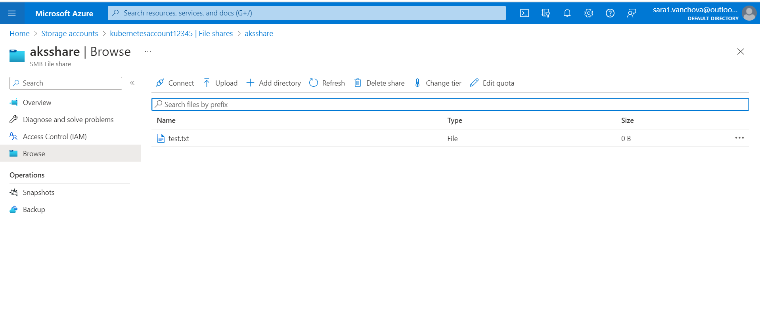

**Practice 2: Provisioning Azure File storage using PVs and PVCs**

1. Login to Azure and connect to your AKS cluster.

2. Check if any pods run under the default namespace if so delete everything under the default namespace.

3. Now we will provision Azure files storage to a pod using PV and PVC.

4. Create a azurefile-mount-options-pv.yaml file with a PersistentVolume like this:

apiVersion: v1

kind: PersistentVolume

metadata:

  name: azurefile

spec:

  capacity:

    storage: 5Gi

  accessModes:

  - ReadWriteMany

  azureFile:

    secretName: azure-secret

    shareName: aksshare

    readOnly: false

  mountOptions:

    - dir_mode=0777

    - file_mode=0777

    - uid=1000

    - gid=1000

    - mfsymlinks

    - nobrl

5. Note the access mode. Can you use other mode with Azure files?

**ReadWriteOnce , ReadOnlyMany , ReadWriteMany**

6. Now create a azurefile-mount-options-pvc.yaml file with a PersistentVolumeClaim that uses the

PersistentVolume like this:

apiVersion: v1

kind: PersistentVolumeClaim

metadata:

  name: azurefile

spec:

  accessModes:

  - ReadWriteMany

  storageClassName: ""

  resources:

    requests:

      storage: 5Gi

7. Execute **kubectl apply -f azurefile-mount-options-pv.yaml** and **kubectl apply -f azurefile-mount-optionspvc.**

**yaml**.

8. Verify your PersistentVolumeClaim is created and bound to the PersistentVolume. Run **kubectl get pvc**

**azurefile.**

9. Now we can embed the PVC info inside our pod definition. Create the following file azure-files-pod.yaml with

following content:

apiVersion: v1

kind: Pod

metadata:

  name: mypod

spec:

  containers:

  - name: mypod

    image: mcr.microsoft.com/oss/nginx/nginx:1.15.5-alpine

    resources:

      requests:

        cpu: 100m

        memory: 128Mi

      limits:

        cpu: 250m

        memory: 256Mi

    volumeMounts:

    - name: azure

      mountPath: /mnt/azure

  volumes:

  - name: azure

    persistentVolumeClaim:

      claimName: azurefile

10. Run **kubectl apply -f azure-files-pod.yaml**.



11. You now have a running pod with an Azure Files share mounted at /mnt/azure.

12. You can use **kubectl describe pod mypod** to verify the share is mounted successfully. Search for the Volumes

section of the output.

13. Now exec to the pod and try to access the mounted file share. Run the following command **kubectl exec -it**

**mypod -- bash**

14. Go to /mnt/azure and create a blank file test.txt file.

15. Go to the portal and locate your Azure storage provisioned for this practice.

16. Under the Files section, check the contents of the Azure file share and check if test.txt file exists.

17. Delete the mypod the pv and pvc you have created so far. What happens to the Azure File share?

**It’s not delete , you can delete this manually. The link is delete between the pod and the file share. But the file share is still happening.**

**Practice 3: Provisioning Azure file storage using Storage Classes**

1. Login to Azure and connect to your AKS cluster.

2. Check if any pods run under the default namespace if so delete everything under the default namespace.

3. Now we will provision file storage using the definition of storage classes. Create a file named azure-file-sc.yaml

and copy in the following example manifest:

apiVersion: storage.k8s.io/v1

kind: StorageClass

metadata:

  name: my-azurefile

provisioner: kubernetes.io/azure-file

mountOptions:

- dir_mode=0777

- file_mode=0777

- uid=0

- gid=0

- mfsymlinks

- cache=strict

- actimeo=30

parameters:

  skuName: Standard_LRS

4. Create the storage class with **kubectl apply -f azure-file-sc.yaml** .



5. Now we will create the PVC that will consume the storage class defined previously. Create a file named azurefile-

pvc.yaml and copy in the following YAML:

apiVersion: v1

kind: PersistentVolumeClaim

metadata:

  name: my-azurefile

spec:

  accessModes:

  - ReadWriteMany

  storageClassName: my-azurefile

  resources:

    requests:

      storage: 5Gi

6. Create the persistent volume claim with the **kubectl apply -f azure-file-pvc.yaml.**

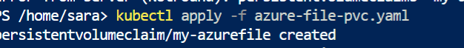

7. Once completed, the file share will be created. A Kubernetes secret is also created that includes connection

information and credentials. You can use the **kubectl get pvc my-azurefile** command to view the status of the

PVC.



8. Now we will create the pod that consumes the PVC. Create a file named azure-pvc-files.yaml, and copy in the

following YAML. Make sure that the claimName matches the PVC created in the last step:

apiVersion: v1

kind: Pod

metadata:

  name: mypod

spec:

  containers:

  - name: mypod

    image: mcr.microsoft.com/oss/nginx/nginx:1.15.5-alpine

    resources:

      requests:

        cpu: 100m

        memory: 128Mi

      limits:

        cpu: 250m

        memory: 256Mi

    volumeMounts:

    - name: volume

      mountPath: "/mnt/azure"

  volumes:

  - name: volume

    persistentVolumeClaim:

      claimName: my-azurefile

9. Create the pod with **kubectl apply -f azure-pvc-files.yaml .**



10. Do a describe on the pod and check the volumes mounted.

11. Delete everything created under this practice including the storage class.

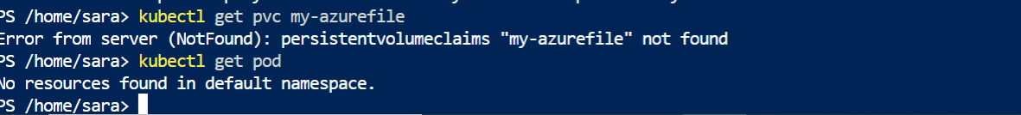

**Practice 4: Direct provisioning of Azure Disk storage**

1. Login to Azure and connect to your AKS cluster.

2. Check if any pods run under the default namespace if so delete everything under the default namespace.

3. In this practice we will directly provision Azure Disk to a pod running inside AKS.

4. First create the disk in the node resource group. First, get the node resource group name with **az aks show --**

**resource-group myResourceGroup --name myAKSCluster --query nodeResourceGroup -o tsv** .



5. Now create a disk using:

az disk create \

--resource-group MC_myResourceGroup_myAKSCluster_eastus \

--name myAKSDisk \

--size-gb 20 \

--query id --output tsv



/subscriptions/6a1ed754-8451-423c-9809-c9c09c25f452/resourceGroups/MC_myrgCluster_myAKSCluster_eastus/providers/Microsoft.Compute/disks/myAKSDisk

6. Make a note of the disk resource ID shown at the end of the script output. This value is needed when you

create the Kubernetes volume in one of the following steps.

/subscriptions/6a1ed754-8451-423c-9809-c9c09c25f452/resourceGroups/MC_myrgCluster_myAKSCluster_eastus/providers/Microsoft.Compute/disks/myAKSDisk

7. Now we can create the pod and mount the Azure Disk. Create a new file named azure-disk-pod.yaml with the

following contents:

apiVersion: v1

kind: Pod

metadata:

  name: mypod

spec:

  containers:

  - name: mypod

    image: mcr.microsoft.com/oss/nginx/nginx:1.15.5-alpine

    resources:

      requests:

        cpu: 100m

        memory: 128Mi

      limits:

        cpu: 250m

        memory: 256Mi

    volumeMounts:

    - name: azure

      mountPath: "/mnt/azure"

  volumes:

  - name: azure

    azureDisk:

      kind: Managed

      diskName: myAKSDiskkk

      diskURI: /subscriptions/6a1ed754-8451-423c-9809-c9c09c25f452/resourceGroups/MC_myrgCluster_myAKSCluster_eastus/providers/Microsoft.Compute/disks/myAKSDiskkk

8. Run **kubectl apply -f azure-disk-pod.yaml**.



9. You now have a running pod with an Azure Disk mounted at /mnt/azure.

10. You can use **kubectl describe pod mypod** to verify the share is mounted successfully. Search for the Volumes

section of the output.

11. Now exec to the pod and try to access the mounted volume. Run the following command **kubectl exec -it**

**mypod – bash**

12. Go to /mnt/azure and try create a blank file test.txt file.

13. Delete everything created by this practice.

**Practice 5: Provisioning Azure Disk storage using Storage Classes**

1. Login to Azure and connect to your AKS cluster.

2. Check if any pods run under the default namespace if so delete everything under the default namespace.

3. Now we will provision Azure disk and attach it to a running pod but this time using dynamic provisioning with

storage classes. List the available storage classes, run **kubectl get sc.**

4. Examine the output. Each AKS cluster includes four pre-created storage classes, two of them configured to

work with Azure disks, default and managed-premium. We will use the managed-premium in our PVC

definition since it uses premium type of disks.

5. Now we will create the PVC that will consume the storage class defined previously. Create a file named azurepremium.

yaml and copy in the following YAML:

apiVersion: v1

kind: PersistentVolumeClaim

metadata:

  name: azure-managed-disk

spec:

  accessModes:

  - ReadWriteOnce

  storageClassName: managed-premium

  resources:

    requests:

      storage: 5Gi

6. Create the persistent volume claim with the **kubectl apply -f azure-premium.yaml.**

7. Check the status of your PVC.





**I have created this before so that is why is unchanged.**

8. Now we will create the pod that consumes the PVC. Create a file named azure-pvc-disk.yaml, and copy in the

following YAML. Make sure that the claimName matches the PVC created in the last step:

kind: Pod

apiVersion: v1

metadata:

  name: mypod

spec:

  containers:

  - name: mypod

    image: mcr.microsoft.com/oss/nginx/nginx:1.15.5-alpine

    resources:

      requests:

        cpu: 100m

        memory: 128Mi

      limits:

        cpu: 250m

        memory: 256Mi

    volumeMounts:

    - name: volume

      mountPath: "/mnt/azure"

  volumes:

  - name: volume

    persistentVolumeClaim:

      claimName: azure-managed-disk

9. Create the pod with **kubectl apply -f azure-pvc-disk.yaml .**



10. Do a describe on the pod and check the volumes mounted.

11. Delete everything created under this practice including the storage class.

